Melissa Yee

100729644 | March 2, 2020

AIDI 2004 – AI in Enterprise Systems

Lab #2 - Cloud

# Step 1

Create user accounts in Google, AWS and Azure platform

## Google Cloud Account

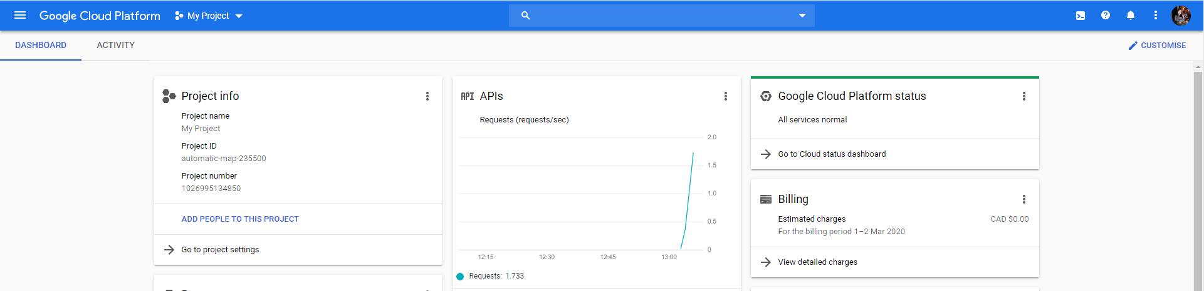



## AWS Account

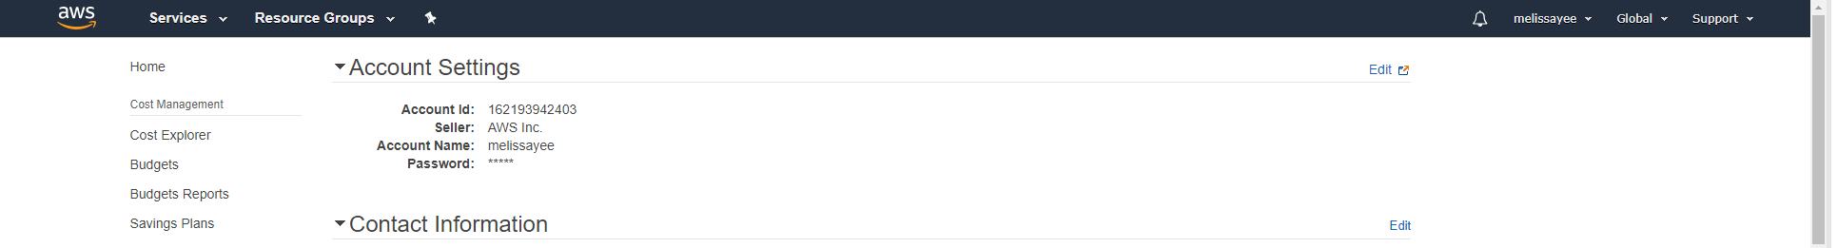



## Microsoft Azure Account





# Step 2



Review key features of these Platform and select one of them as your working platform. Justify your selection.

|  |  |  |
| --- | --- | --- |
|  | **Pros** | **Cons** |
| **Google Cloud** | * Prior experience using platform * Provides free credits rather than free tier, meaning you can use stronger machines if desired * More open source technologies, eg. Kubernetes * TensorFlow built by Google * Pricing can be billed by the second | * Google CoLab acts separately from the Google Cloud services although it can be integrated * Fewer services compared to competitors |
| **AWS** | * Minimal experience using platform * Provides free tier of services * Has dedicated service for machine learning integrated within AWS (SageMaker) * Most popular service * Pricing can be billed by the second | * Free tier of services means that you can’t use more powerful resources on a free trial |
| **Microsoft Azure** | * Integrates seamlessly with all Microsoft products, which are very widespread * Comparable prices to AWS * Fastest cloud service | * No prior experience using platform * Pricing is by the hour, less flexible than Google Cloud and AWS |

Based on the above chart, I have decided to use Google Cloud. I have used using Google Cloud before in a prior project. I believe it will best suit my needs because of my experience with it, the way the free credits work, and I feel it will integrate well with all other platforms.

# Step 3

Configure a virtual machine (VM) in your selected platform

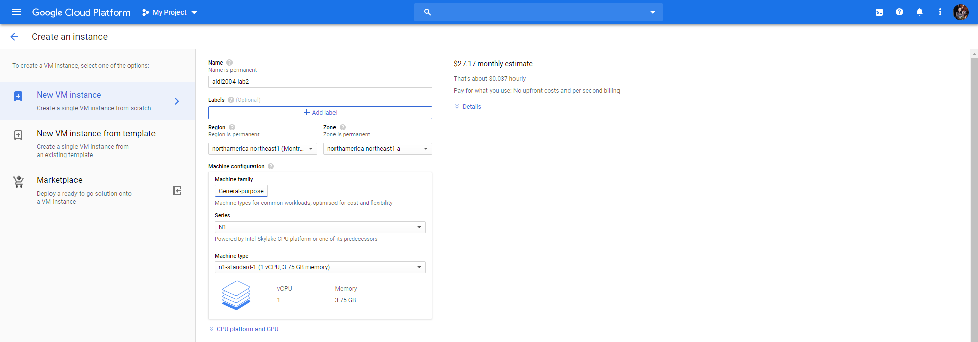

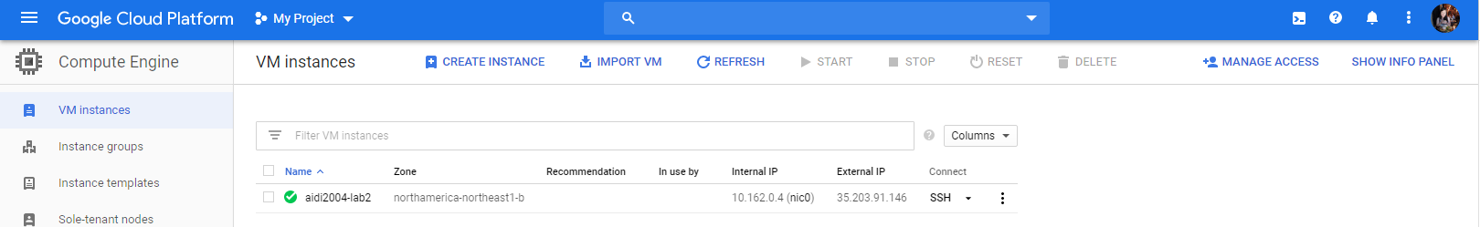

# Step 4

Run your VM and create a folder in your machine.

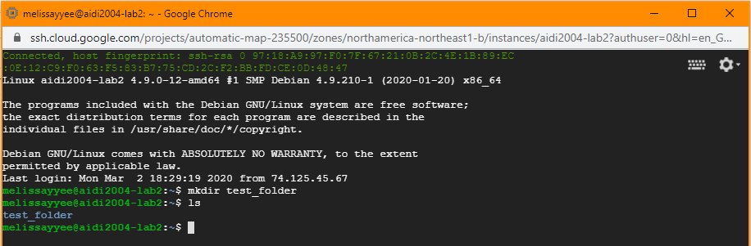

# Step 5

Write a basic python program to perform basic math operations of two variables and save that program in the folder

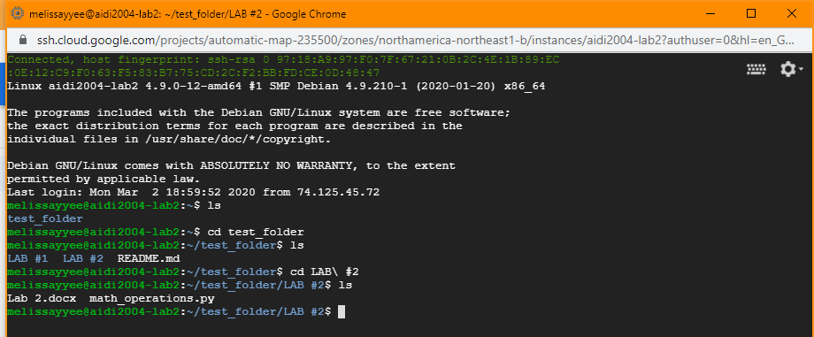

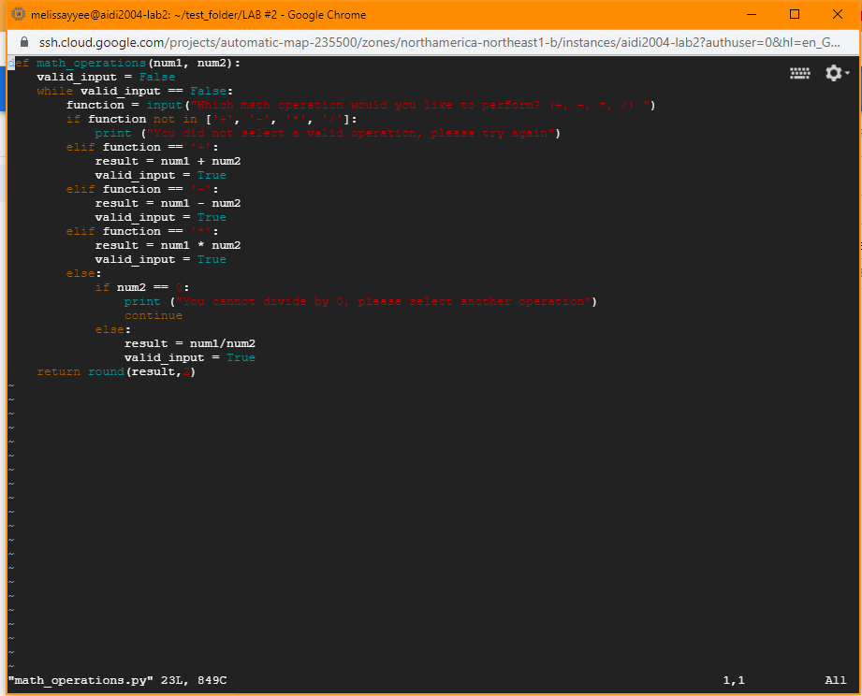Step 6

# Step 6

Create a repo in your remote git host

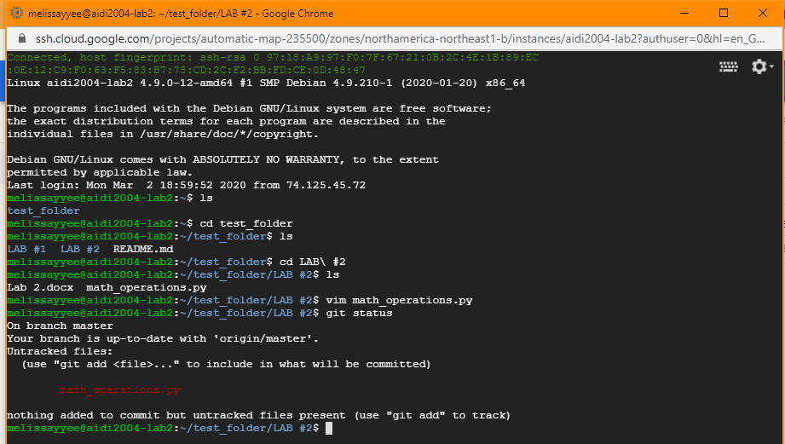

# Step 7

Push your new code in that repo

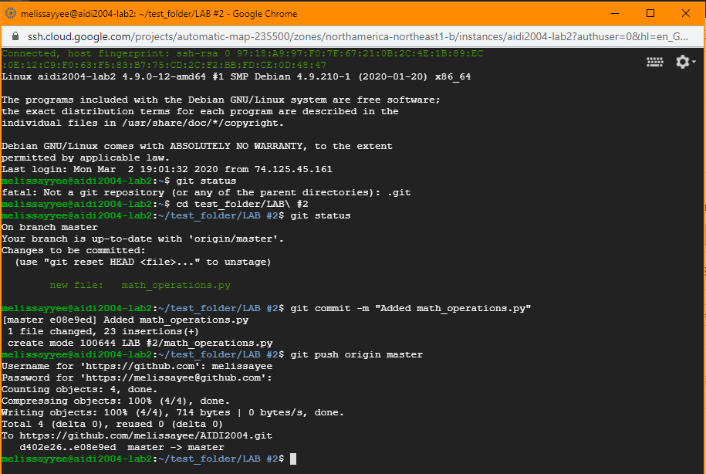

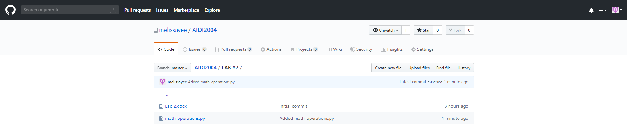

# Step 8

If AWS is your cloud, navigate to your SageMaker and create a Notebook instance in SageMaker

If you are not using AWS, Navigate to Google Colab

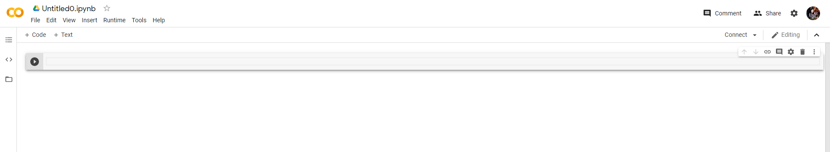

# Step 9

Create Jupyter Notebook in SageMaker/ Google Colab. Perform basic math operations in the notebook

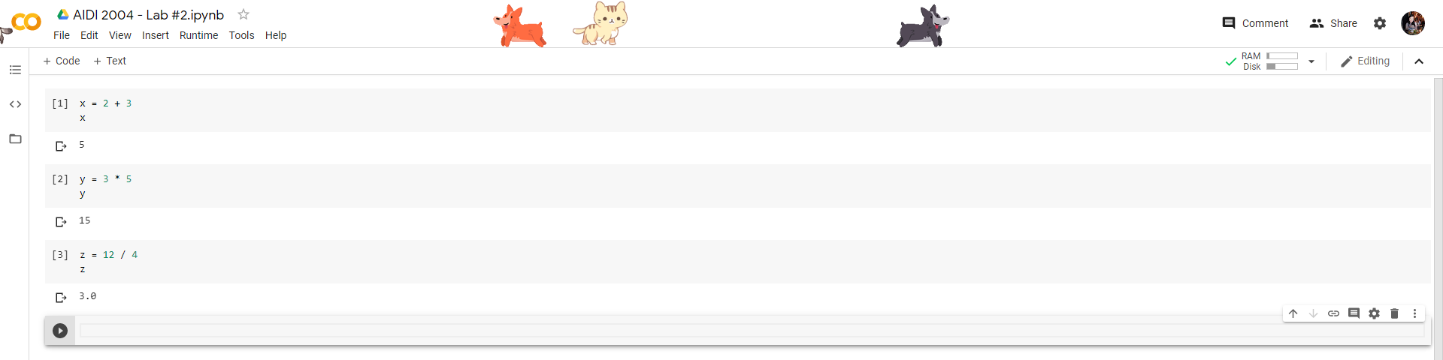

# Step 10

Upload load your notebook in your git repo

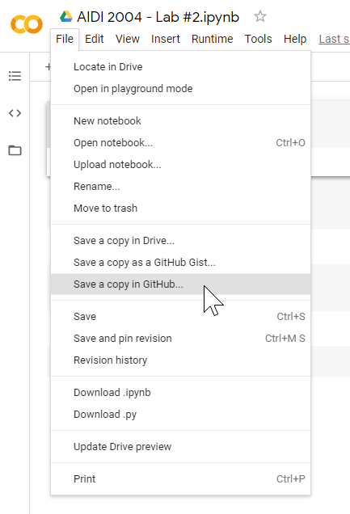

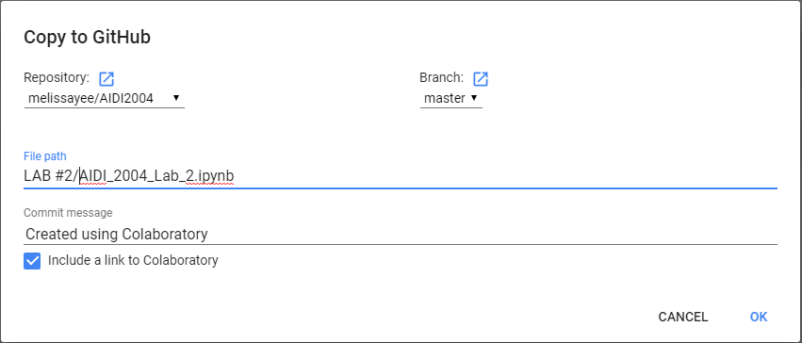

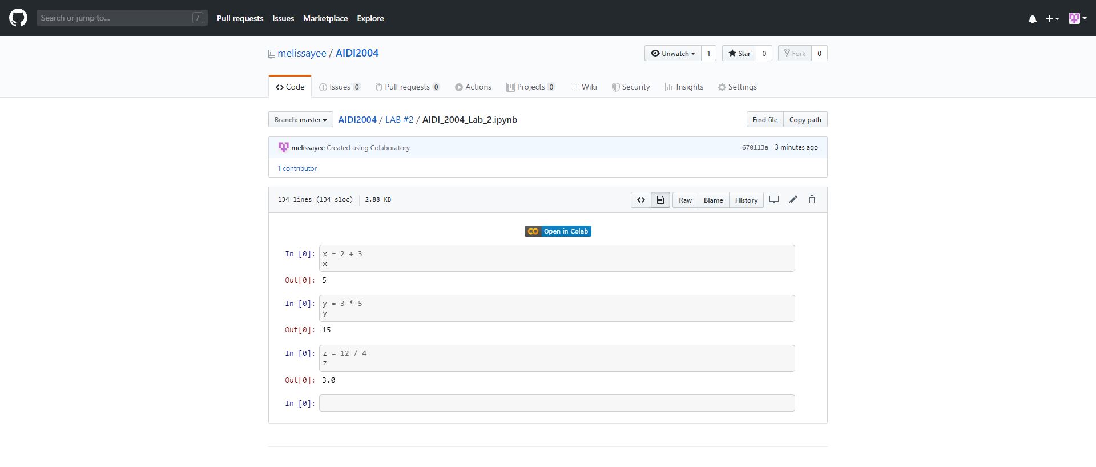

GitHub repository link: <https://github.com/melissayee/AIDI2004/tree/master/LAB%20%232>